ITEM DETAILS
Name of Item | Inter-War Flats
Other Name/s  Former Name/s | 17-17A Ocean Street North, Bondi
Item type | Built
Item group | Flat Building
Item category | Flat
Area, Group, or Collection Name | Unknown
Street number | 17-17A
Street name | Ocean Street North
Suburb/town | Bondi |  |  |  |  | Postcode |  |  | 2026
Local Government Area/s | Waverley
Property description | SP 5012  SP 14025
Location - Lat/long | Latitude | -33.891175 |  | Longitude | 151.262607
Location - AMG (if no street address) | Zone |  |  | Easting |  |  |  | Northing
Owner | Private
Current use | Residential
Former Use | Residential
Statement of significance | 17 Ocean Street, Bondi is a fine example of a two-storey Inter-War Functionalist flat building that is part of a group of Inter-War flat buildings.  17A Ocean Street, Bondi is a fine example of a three-storey Inter-War Art Deco and Inter-War Old English style flat building that is part of a group of Inter-War flat buildings.  17 – 17A Ocean Street, Bondi, represents the development of Inter-War flat buildings, an important phase in the history of Waverley which represents the 1920s-1930s development boom, a prominent period of economic prosperity and speculative development in Waverley associated with the changing demographics with a shift to living in flats.  It also demonstrates the demolition of villa residences and their replacement with flats in the Inter-War period, an important historical development pattern in the area.
Level of Significance | National |  | State |  |  |  | Local

DESCRIPTION
Designer

Builder/ maker

Physical Description | No 17 Ocean Street, Bondi is a two-storey flat building that is part of a group that dates from the Inter-War period, a key period of significance of the Bondi area. The building displays features of the Inter-War Functionalist style with curved projecting bays, parapet concealing the roof, plain face brick walls with contrasting horizontal liver brick banding, fenestration in horizontal bands, return corner windows and horizontal glazing bars. The building is set on an elevated site approximately 15 metres wide, that has been subdivided in a suburban setting that has partially lost its historic context. The site features a face-brick fence approximately 1.5m high and a double garage of face brick which dates from the Inter-War period. The site is sparsely landscaped and features a side path, steps, and lawn. The street trees provide an appropriate landscaped setting for the building.  The building appears to be in good condition and is highly intact.  No.17A Ocean Street, Bondi is a three-storey flat building that is part of a group that dates from the Inter-War period, a key period of significance of the Bondi area. The building displays features of the Inter-War Art Deco and Inter-War Old English style with stepped building form, stepped and gabled parapet, decorative face brickwork, parallel line motif, vertical fin, and basket weave brick. The building is setback 6 metres from the street on an elevated site approximately 12 metres wide, that has been subdivided in a suburban setting that has partially lost its historic context. The site features two pairs brick and sandstone garages on the street with panelled garage doors which dates from 1939, which compliments the setting of the place. The site is formally landscaped and features a central path, steps, and hedging. The street trees provide an appropriate landscaped setting for the building. The building has 4 flats per floor with side entry (Type 2). The building appears to be in good condition and is highly intact.  Elements impacting upon the integrity of the site include security bars.
Physical condition  and  Archaeological potential | The building appears to be in good condition.
Construction years | Start year | 1906 | Finish year | 1939 | Circa
Modifications and dates | 17A Ocean Street, Bondi had smaller skillion rear extension prior 1943.

HISTORY
Historical notes | 17-17a Ocean Street, Bondi was part of a Victorian subdivision of 89 Allotments of land near Council Chambers, Waverley (Z/SP/W6/472, SLNSW). The 1892 Detail Survey (Waverley Sheet 18, SLNSW) shows the street developed with Victorian villa residences. The Victorian villas were demolished, and the original lots were resubdivided for flat development in the 1930s. In 1939, plans for proposed residential flats of (No.17a) Ocean Street for C.J. Harlowe Esq were approved.

THEMES
 | National historical theme | 4 Building settlements, towns and cities  8 Developing Australia’s Cultural Life
 | State  historical theme | Towns, suburbs and villages  Accommodation  Domestic life  Creative endeavour
 | Local  historical theme | Flats and Bungalows  Speculation and Subdivision

Assessment
A: Historical Significance | 17 – 17A Ocean Street, Bondi has historical significance at a local level as it represents the development of Inter-War flat buildings, an important phase in the history of Waverley which represents the 1920s-1930s development boom, a prominent period of economic prosperity and speculative development in Waverley associated with the changing demographics with a shift to living in flats.  17 – 17A Ocean Street, Bondi has historical significance at a local level as it demonstrates the demolition of villa residences and their replacement with flats in the Inter-War period, an important historical development pattern in the area.
B: Associative | To date no historic association has been identified.
C: Aesthetic significance | 17 Ocean Street, Bondi has aesthetic significance at a local level as a fine example of a two-storey Inter-War Functionalist flat building that is part of a group of Inter-War flat buildings. The building shows an accomplished use of Inter-War Art Deco style which features projecting bays, parapet concealing the roof, plain face brick walls with contrasting horizontal liver brick banding, fenestration in horizontal bands, return corner windows and horizontal glazing bars.  17A Ocean Street, Bondi has aesthetic significance at a local level as a fine example of a three-storey Inter-War Art Deco and Inter-War Old English style flat building that is part of a group of Inter-War flat buildings. The building shows an accomplished use of Inter-War Art Deco and Inter-War Old English style which features stepped building form, stepped parapet, decorative face brickwork, parallel line motif, vertical fin and basket weave brick.
D: Social significance | To date no social, cultural, and spiritual significance has been identified.
e) Technical/  Research significance | To date no research/technical significance has been identified.
f) Rarity | To date the research indicates 17 – 17A Ocean Street, Bondi are not rare.
g) Representative-ness | 17 Ocean Street, Bondi has representative significance at a local level as a fine example of a two-storey Inter-War Functionalist flat building flat that is part of a group of flat buildings.  17A Ocean Street, Bondi has representative significance at a local level as a fine example of a three-storey Inter-War Art Deco and Inter-War Old English-style flat building that is part of a group of flat buildings.
Integrity | The building is highly intact.

HERITAGE LISTINGS
Heritage listing/s | Draft Waverley LEP 2012

INFORMATION SOURCES
Type | Author/Client | Title | Year | Repository
 | Waverley Council | Waverley Heritage Policy | 2007
 | Waverley Council | Waverley Heritage Study | 1993
 | Perumal Murphy Pty Ltd | Waverley Heritage Study | 1990
 |  | Waverley Detail Survey, Sheet 18 | 1892 | State Library NSW
 |  | Z/SP/W6/472 |  | State Library NSW

RECOMMENDATIONS
Recommendations

SOURCE OF THIS INFORMATION
Name of study or report | Heritage Policy by Waverley Council reviewed by Architectural Projects 2023 |  | Year of study or report
Item number in study or report

Author of study or report
Inspected by
NSW Heritage Manual guidelines used? |  |  |  | Yes |  | No
This form completed by |  |  |  | Date

IMAGES

Image caption | 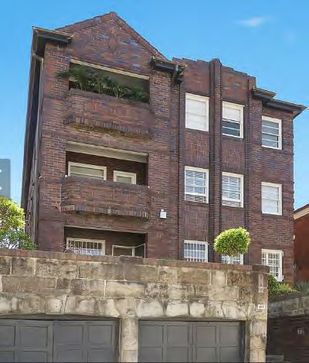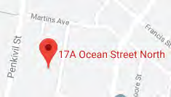
Image year |  | Image by | Google Maps | Image copyright holder

Image caption | 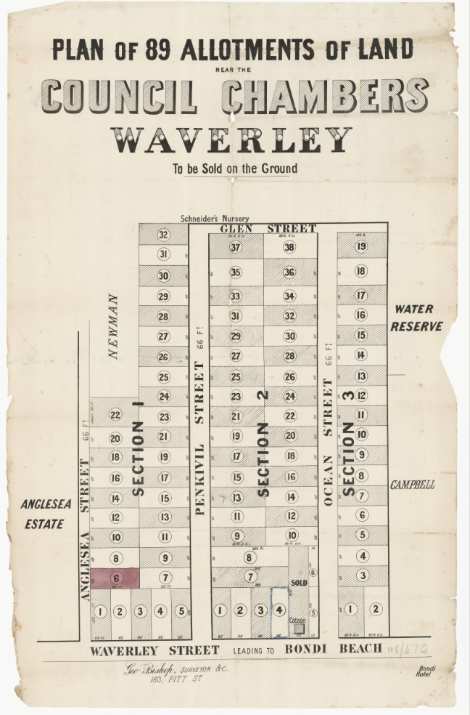
Image year | Undated | Image by | State Library of New South Wales | Image copyright holder

Image caption | 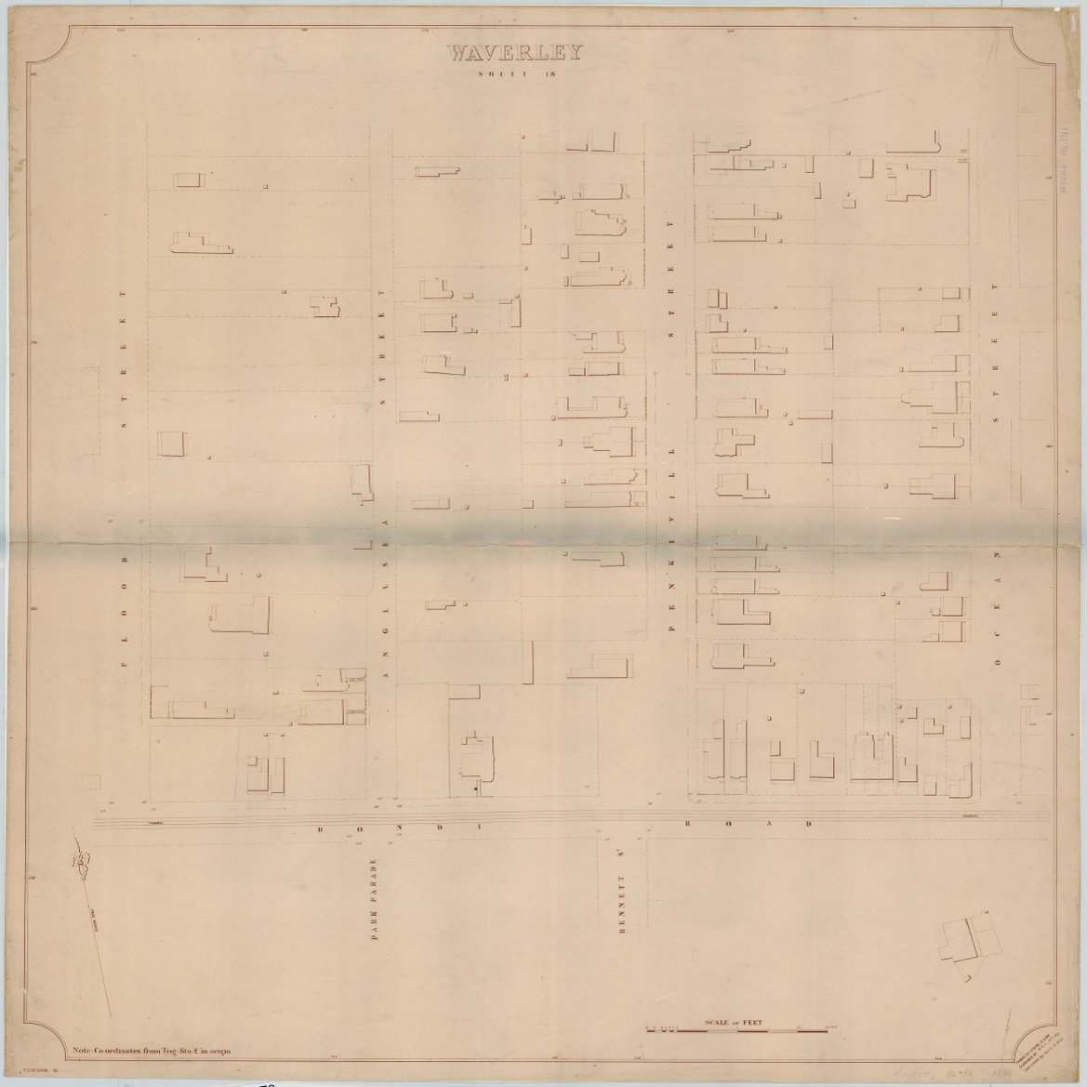
Image year | 1892 | Image by | State Library of New South Wales | Image copyright holder

Image caption | 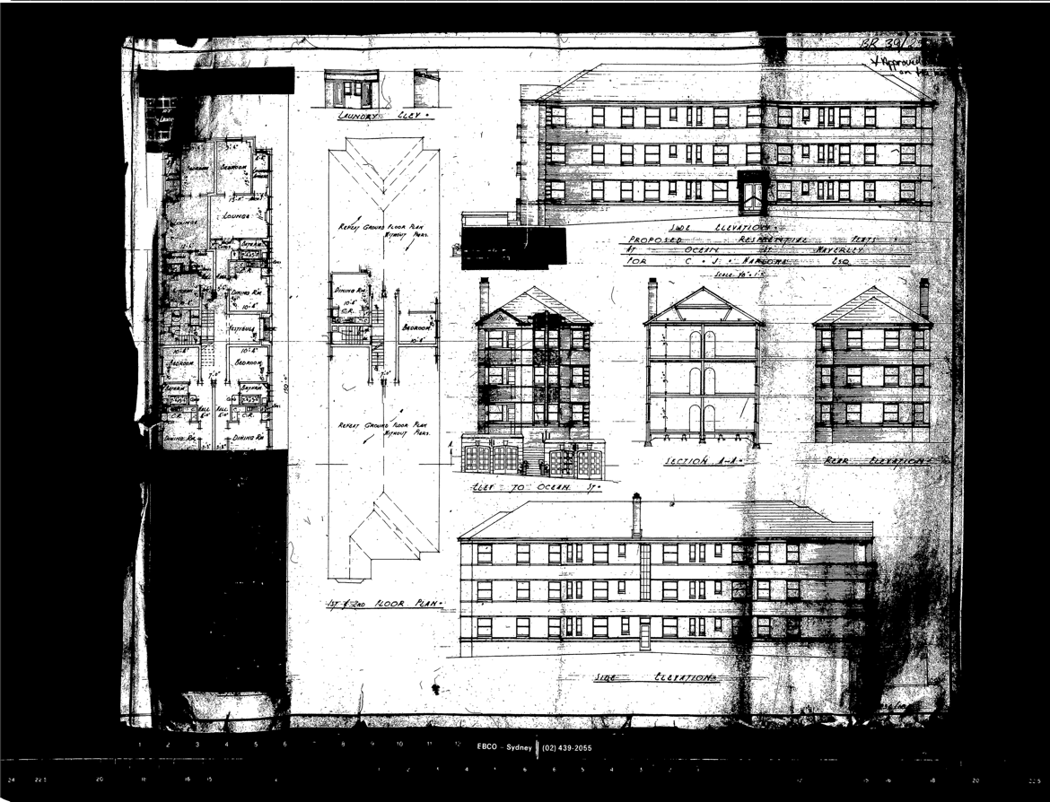
Image year | 1939 | Image by | Waverley Council | Image copyright holder

Image caption | 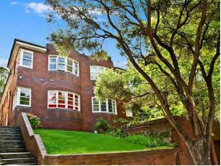
Image year |  | Image by | Google Maps | Image copyright holder

Image caption | 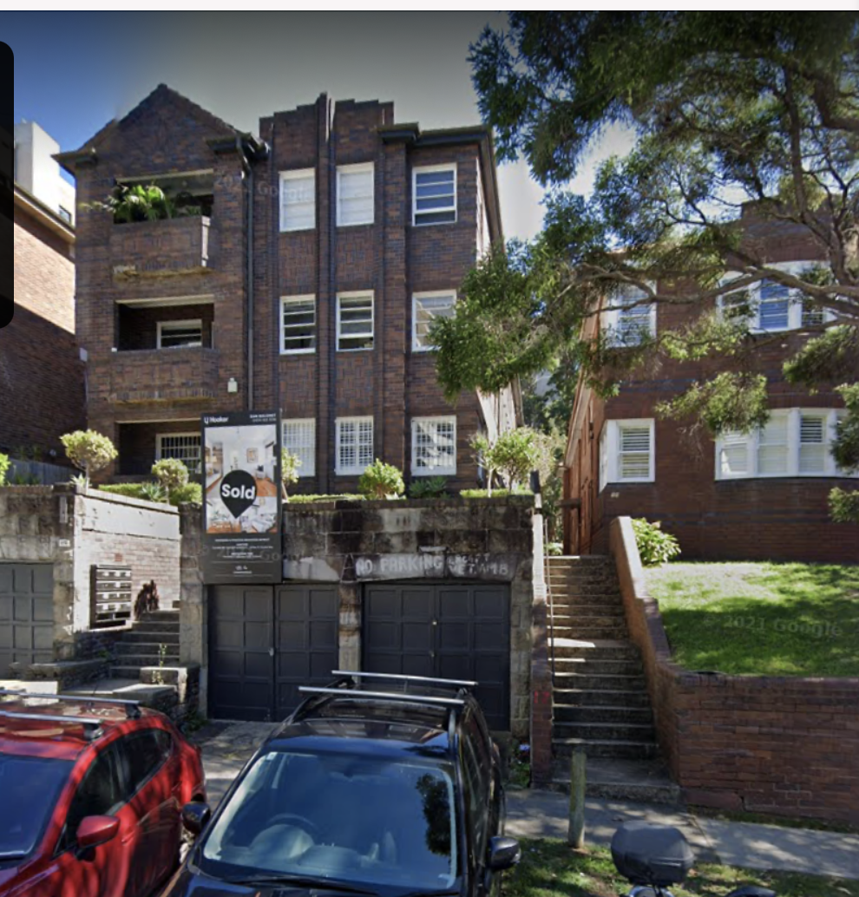
Image year |  | Image by | Google Maps | Image copyright holder

